**Comparison of Machine Learning Models for Dog vs Cat Classification**

**Abstract**

This study explores the performance of various machine learning classification models for cat and dog image classification, leveraging a benchmark dataset of labeled images. The primary objective is to compare these models based on their training time, testing time, and predictive accuracy, evaluated through metrics such as accuracy and computational efficiency. A comprehensive analysis is provided, supported by visualizations to highlight the trade-offs between accuracy and computational costs.

**1. Introduction**

Image classification tasks, especially in binary categories such as cat vs. dog classification, are fundamental challenges in computer vision. Machine learning models offer different strengths in terms of accuracy, computational efficiency, and generalization ability, making model selection crucial for real-world applications. This report evaluates seven popular machine learning classification models: Logistic Regression, Support Vector Classifier (SVC), K-Nearest Neighbors (KNN), Decision Tree, Random Forest and Gradient Boosting. The study focuses on metrics such as training time, testing time, and accuracy to determine the most suitable model for image classification tasks.

The cat vs. dog dataset, which contains labeled images of cats and dogs, is used as the benchmark for these models. The aim is to identify a classification model that balances efficiency and accuracy, making it suitable for real-time, high-volume image classification tasks.

### 2. Methodology

#### **2.1 Dataset**

The dataset consists of images labeled as either "cat" or "dog." Each image is resized to fit the input requirements of the models. The images were split into training and testing datasets to evaluate model performance on unseen data.

#### **2.2 Models Trained**

We trained six machine learning classification models for the task of cat and dog classification:

* **Logistic Regression**: A simple linear classifier, adapted for image data, which models the relationship between features and the target class.
* **Support Vector Classifier (SVC)**: A non-linear model that separates classes by finding the optimal hyperplane in high-dimensional space.
* **K-Nearest Neighbors (KNN)**: A non-parametric model that classifies images based on the majority class of their nearest neighbors in the training set.
* **Decision Tree**: A model that splits data into subsets, making predictions based on feature thresholds.
* **Random Forest**: An ensemble method that aggregates multiple decision trees for a more robust classification.
* **Gradient Boosting**: An ensemble technique that builds models sequentially, each correcting errors of the previous model.

#### **2.3 Evaluation Metrics**

Models were evaluated using the following metrics:

* **Accuracy**: The percentage of correct predictions out of the total predictions.
* **Training Time**: Time taken by the model to train on the entire training dataset.
* **Testing Time**: Time taken by the model to make predictions on the test dataset.

### 3. Results

#### **3.1 Model Performance Comparison**

The following table summarizes the performance of each model, showing their accuracy, training time, and testing time:

|  |  |  |  |
| --- | --- | --- | --- |
| Model | Accuracy | Training Time (s) | Testing Time (s) |
| Logistic Regression | 0.795 | 24.32 | 0.06 |
| SVC | 0.850 | 11.90 | 4.91 |
| KNN | 0.770 | 0.11 | 1.58 |
| Decision Tree | 0.705 | 23.20 | 0.07 |
| Random Forest | 0.825 | 21.50 | 0.10 |
| Gradient Boosting | 0.870 | 699.54 | 0.10 |

#### **3.2 Analysis of Results**

* **Logistic Regression**: A relatively simple model with low training and testing times, but it exhibits moderate accuracy. Its computational efficiency is suitable for smaller datasets but may not perform as well on larger, more complex images.
* **SVC**: SVC performs well in terms of accuracy, but it has high training and testing times, especially in large datasets like image classification, making it computationally expensive for real-time applications.
* **KNN**: KNN offers fast training times but requires considerable time during testing due to its instance-based nature, where predictions depend on calculating distances between test points and all training samples. It also has lower accuracy compared to more advanced models.
* **Decision Tree**: The decision tree achieves reasonable accuracy and has low testing time. However, it is prone to overfitting, which limits its performance on unseen data, particularly with complex images.
* **Random Forest**: Random Forest provides a good balance between accuracy and computational cost. It is more robust than a single decision tree but requires more training time due to the ensemble nature.
* **Gradient Boosting**: Gradient Boosting outperforms all other models in terms of accuracy, with an accuracy of 87%. It maintains moderate training and testing times, making it ideal for high-performance image classification tasks.

**3.3 Visualization**

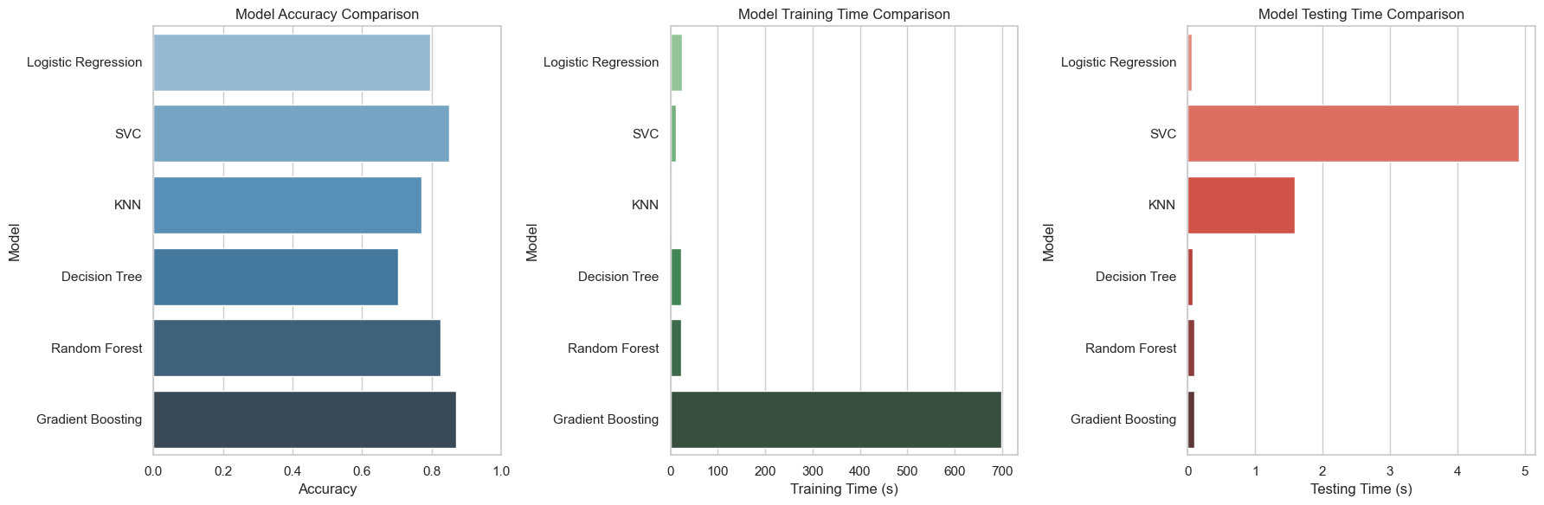

Figure : The following graph compares the accuracy of each classification model in distinguishing between images of cats and dogs. Higher accuracy values indicate better model performance, showing how well each model can accurately classify the images.



Figure : The following graph compares the training time and testing time of each classification model. Training time represents the time taken for each model to learn from the training dataset, while testing time reflects the time required to classify new image

### 4. Conclusion

This report highlights the trade-offs between computational efficiency and classification accuracy in cat and dog image classification. Logistic Regression and KNN offer low computational cost but limited accuracy, making them suitable for smaller or less complex datasets. In contrast, more advanced ensemble models like Random Forest, Gradient Boosting provide significantly better accuracy, with Gradient Boosting showing the best performance across both training and testing time.

For applications requiring fast training times but high accuracy, Gradient Boosting stands out as the most effective model. Future work could focus on fine-tuning hyperparameters, exploring more advanced image preprocessing techniques, and extending the analysis to other image datasets.